Land prices: UNCOVERED!
Extricating land price indexes from improved property price indexes for New Zealand

Frances Krsinich

NZAE conference, July 2019, Wellington

The Sales Appraisal Fixed Effects decomposition
MBIE has been investigating a new approach for decomposing property price indexes into land and structure components. We call this method the Sales Appraisal Fixed Effects decomposition – SAFE(d).
In addition to an improved property price measure for New Zealand which better controls for quality change, this new approach gives improved land price indexes and the potential for price-to-cost measures for the full stock of New Zealand property, all of which can be disaggregated down to the territorial authority (TA) level.

Measuring property price change is challenging
Property price change is difficult to measure well, because properties are unique and sell infrequently. This makes it hard to use traditional index number methods to ensure quality adjusted price change measures because we can’t define a ‘fixed basket’ of products and because there is insufficient information on characteristics of properties, or the value to consumers of those characteristics.
However, New Zealand is fortunate to have very rich property data that links sales prices to valuation data, and this enables the Sales Price Appraisal Ratio (SPAR) method to be used for both the QVHPI index produced by CoreLogic, and now the REINZ house price index which until recently used a stratified median measure. Dubner and Krsinich (2010) outline the issues of property price measurement and give an early stocktake of house price measures in New Zealand and Australia.
While a hedonic price index is considered the gold standard for property price measurement, the SPAR method is recognised as one of the better property price index methods in the absence of sufficient data on characteristics to produce a hedonic index (OECD, 2013).

Recently developed methodology means that data on the characteristics of properties is not required for quality adjustment
Recent developments in multilateral price idex methods have enabled the estimation of price indexes from scanner and online data where there is no characteristic information for explicit quality adjustment, by taking advantage of the longitudinal nature of the data and controlling at the level of the product. These fixed effects window splice (FEWS) indexes have been shown to be equivalent to time-dummy hedonic indexes (Krsinich, 2016). And those time-dummy hedonic indexes have in turn been expressed in terms of more traditional index number theory (de Haan & Krsinich, 2017).
Stats NZ have been at the forefront internationally of adopting these methods to measure price change using big data (Bentley & Krsinich, 2017).
The FEWS index method can be extended to the case of property data and, in particular, has been used recently by Stats NZ and MBIE to develop a rental price index based on tenancy bond data from MBIE (Bentley, 2018). From 2019 this rental index has been incorporated into the New Zealand Consumers Price Index (Stats NZ, 2019).

New Zealand’s rich property data enables decomposition into land and structure components
The richness of New Zealand property sales and valuation data means we can produce a more robust property price index than the SPAR method by using a FEWS index which, in the context of property prices, we call the Sales Appraisal Fixed Effects (SAFE) index.
Further, we can estimate the land and structure components of the overall property sale price by applying the relevant ratios derived from the most recent land and property valuations to the sale price of the property. By estimating the SAFE index separately for each of the land, structure and combined property sales prices we can decompose the property price index into land and structure components. We call these the Sales Appraisal Fixed Effects decomposition indexes – the SAFE(d) indexes.
This adds to the current literature on decomposition of property price indexes into land and structure components, such as the hedonic ‘builder’s model’ described in de Haan, Diewert and Hendriks (2011) and developed further in Diewert and Shimizu (2015).
In this paper we present SAFE(d) indexes using 25 years of New Zealand property data from CoreLogic. Once fully developed, these measures are likely to be incorporated into the suite of housing and property measures produced and disseminated by MBIE and the Ministry for Housing and Urban Development (HUD).
Note that these preliminary results are based on a 1% sample of sold properties for the national (NZ) indexes and 10% samples of sold properties at the territorial authority (TA) level for the city indexes. Note also that they are flow, rather than stock, measures. Corresponding stock indexes are a straighforward extension of the method.

The Sales Appraisal Fixed Effects decomposition will give us new insight into the New Zealand property market

Residential land prices in New Zealand have increased eight-fold over the last 25 years
The land price index in 2018 is 9.27, compared to the base value of 1 at 1993.
Figure 1. New Zealand residential land prices
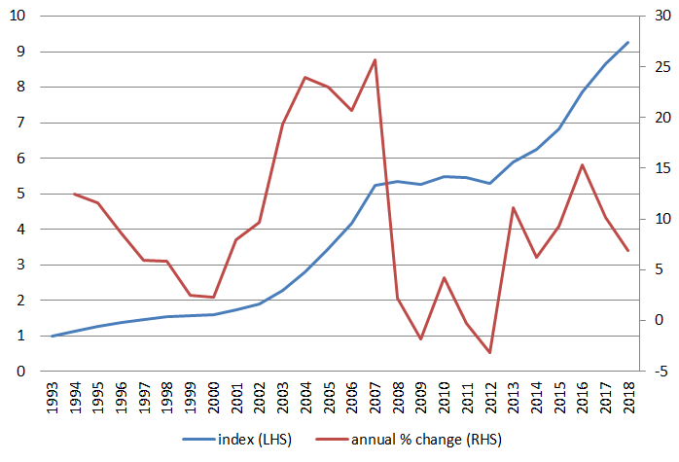

Auckland city residential land prices have increased at more than twice the rate of Christchurch city
The Auckland city land price index in 2018 is 13.7, compared to the Christchurch city land price index of 5.6.
Figure 2. Auckland city residential land prices compared to Christchurch city
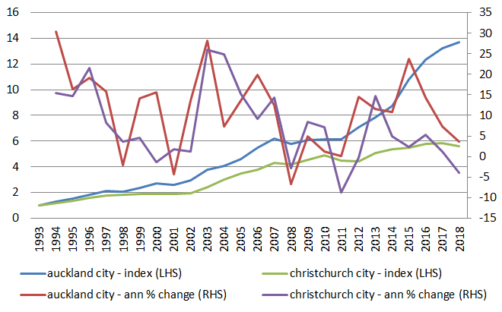

Land prices contributed one-third of the increase in NZ residential property prices over the last 25 years
New Zealand property prices rose 490% over the last 25 years. Structure prices increased 330%. So the 830% increase in land prices over the same period contributed 33% of the increase in New Zealand property prices.
Figure 3. New Zealand residential property, structure and land prices
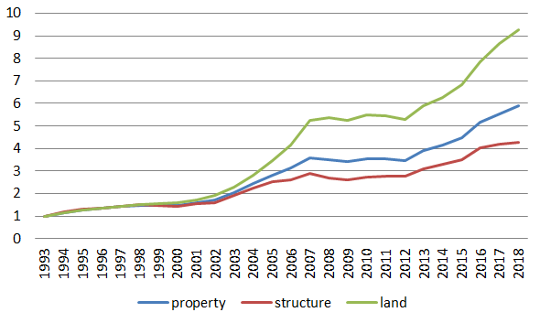

Improved land price indexes and price-cost ratios can be estimated using the SAFE(d) approach
Land price indexes for New Zealand are currently based directly on valuation data, which lags the market value reflected by sales prices.
MBIE has also produced a sales-price appraisal ratio (SPAR) index split into land and structure components as part of its National Policy Statement on Urban Development Capacity (NPS-UDC) dashboard but this has not been widely disseminated outside the context of the NPS-UDC. Unlike the SPAR, the SAFE(d) approach incorporates independent error terms for each of the land, structure and total property models, so it will less biased by the implicit models used by individual valuers when assessing the implicit value of the land component of properties that include a dwelling.
An obvious extension of the SAFE(d) index will be to derive price-to-cost (ie property to structure) ratios for the entire New Zealand residential property stock. Currently these measures are available only for stand-alone houses and use proxied construction costs for structure prices (MBIE & MfE, 2017).

Conclusion
We have shown that extending recently developed multilateral price index methods to property data will give us useful new measures to provide a much richer picture of New Zealand’s property market.
The appendix shows the full set of preliminary results for New Zealand and four main cities (defined at the territorial authority level).

References
Armstrong, J., Dunstan, A., Irrcher, T. (2017). Evaluating alternative monthly house price measures for New Zealand. Reserve Bank of New Zealand Analytical Note Series. ISSN 2230-5505
De Haan, J. & Diewert, W.E. & Hendriks, R. (2011). Hedonic Regressions and the Decomposition of a House Price Index into Land and Structure Components. Econometric Reviews. 34. 10.1080/07474938.2014.944791.
De Haan, J. & Krsinich, F. (2017). Time Dummy Hedonic and Quality-Adjusted Unit Value Indexes: Do They Really Differ?. Review of Income and Wealth. 64. 10.1111/roiw.12304.
Diewert, W.E & Shimizu, C. (2015). Residential property price indices for Tokyo. Macroeconomic Dynamics. -1. 1-56. 10.1017/S1365100514000042.
Dubner, M. & Krsinich, F. (2010). House price measurement in New Zealand and Australia. Paper presented at the 2010 UNECE/ILO Meeting of the group of experts on Consumer Price Indices, Geneva, Switzerland.
Bentley, A. & Krsinich, F . (2017) Towards a big data CPI for New Zealand. Paper presented at the 2017 Ottawa Group, Eltville, Germany.
Bentley, A. (2018). Rentals for housing: A model-based estimator of inflation from administrative data. Paper presented at the 2018 Meeting of the Group of Experts on Consumer Price Indices, Geneva, Switzerland
Krsinich, Frances. (2016). The FEWS index: Fixed effects with a window splice. Journal of Official Statistics. 32. 10.1515/jos-2016-0021.
MBIE & MfE (2017). National Policy Statement on Urban Development Capacity. Price efficiency indicators technical report: Price-cost ratios. Ministry of Business, Innovation & Employment and Ministry for the Environment technical report.
OECD (2013). Handbook on Residential Property Prices Indices (RPPIs). Eurostat Methodologies and Working papers. Luxembourg.
REINZ (2017). REINZ House Price Index. Information note on REINZ website.
Stats NZ (2019) New methodology for rental prices in the CPI. Information note on Stats NZ website.

Appendix
Indexes | Annual % change
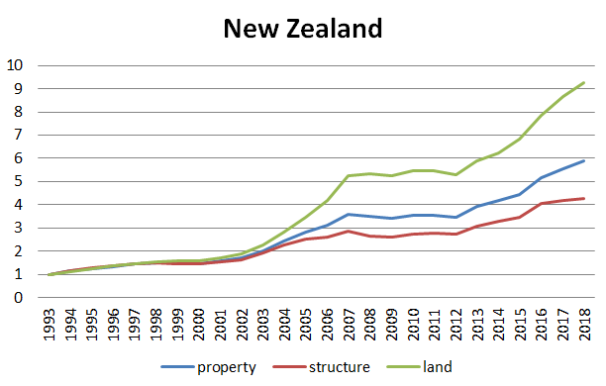 | 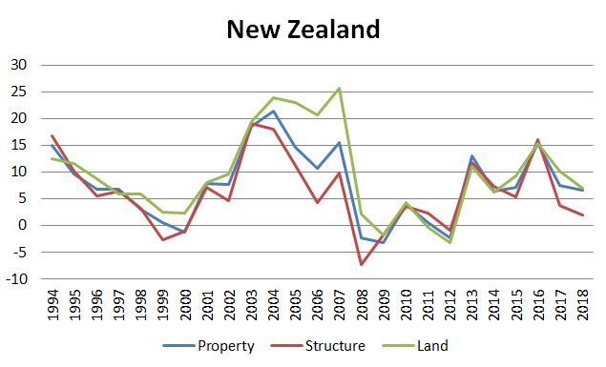
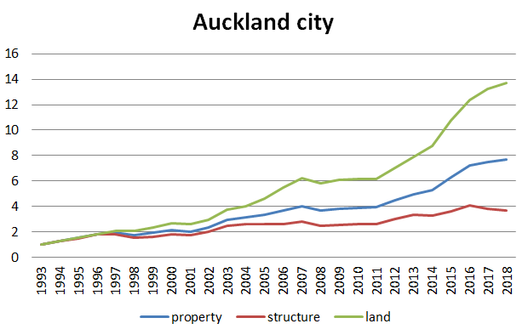 | 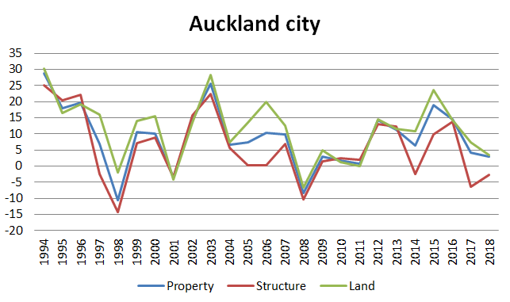
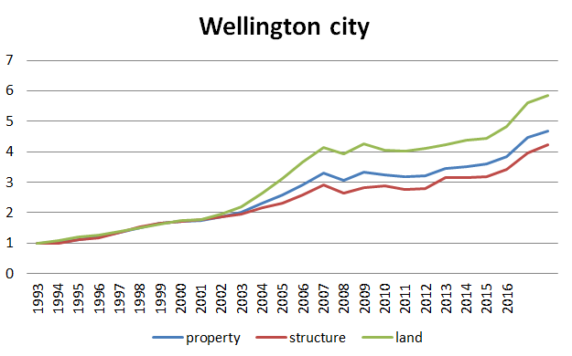 | 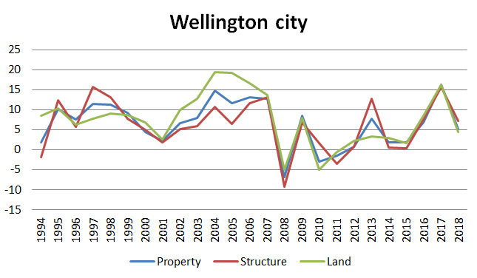
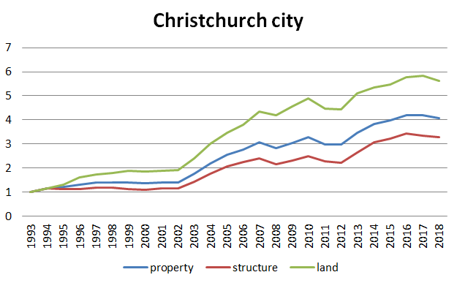 | 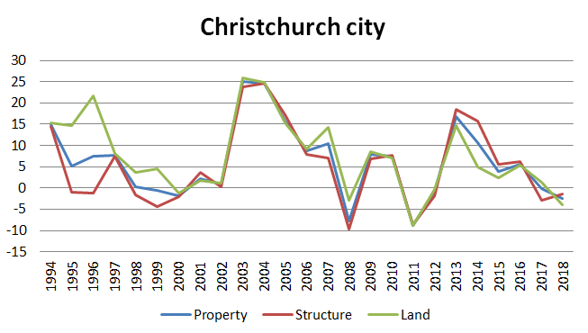
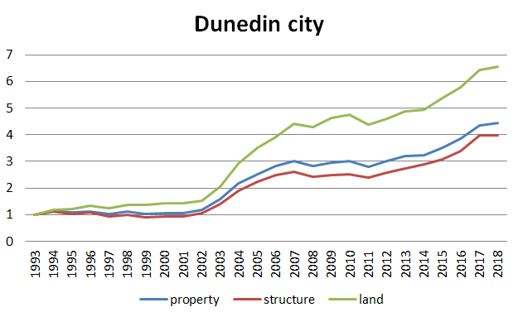 | 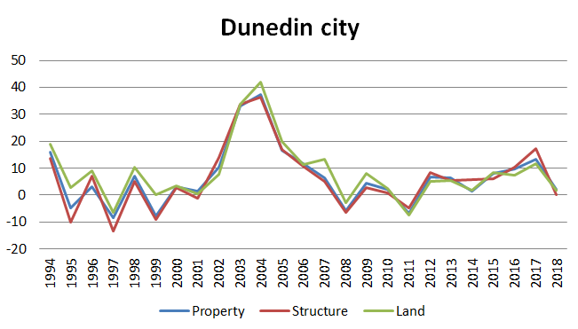

Indexes | Annual % change
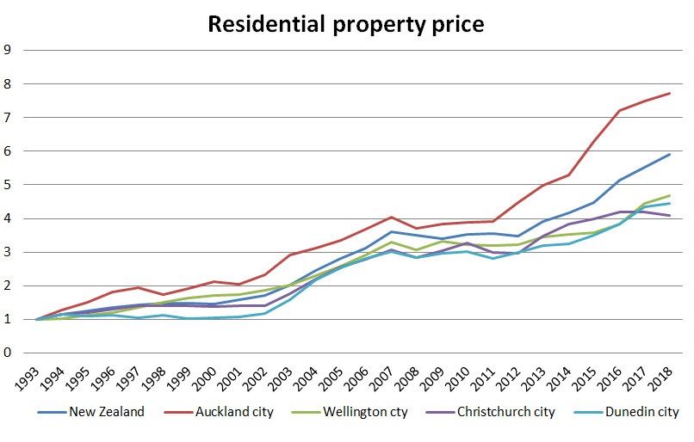 | 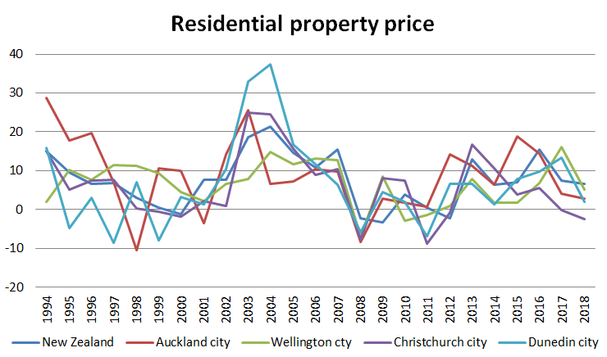
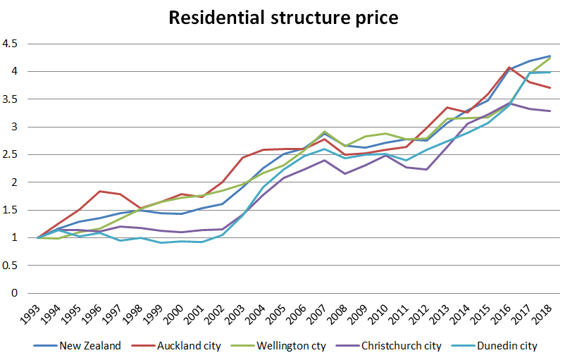 | 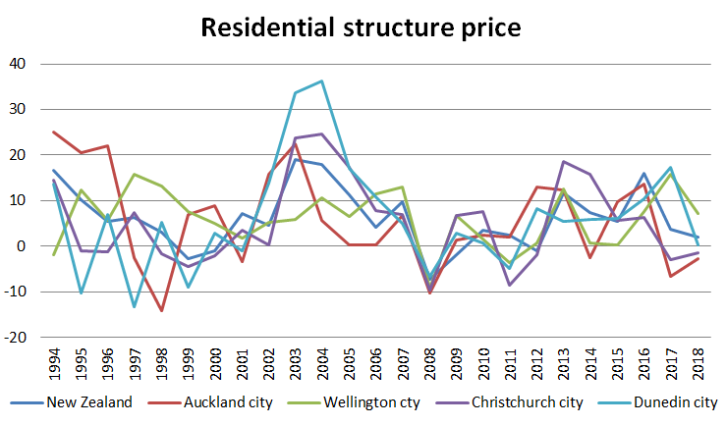
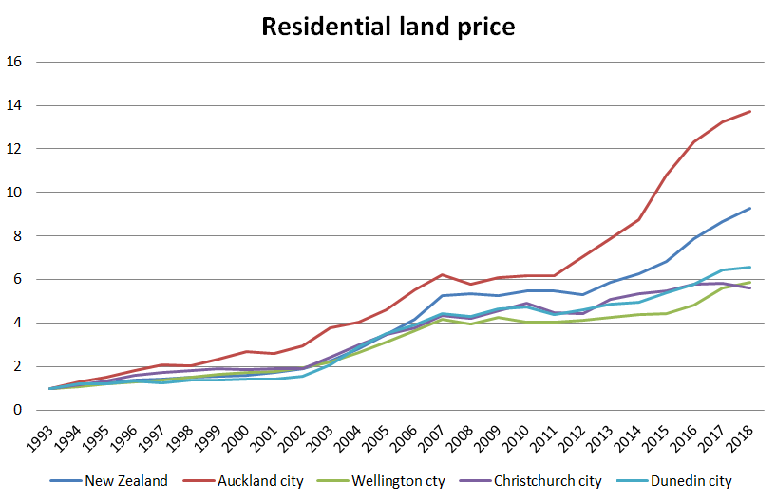 | 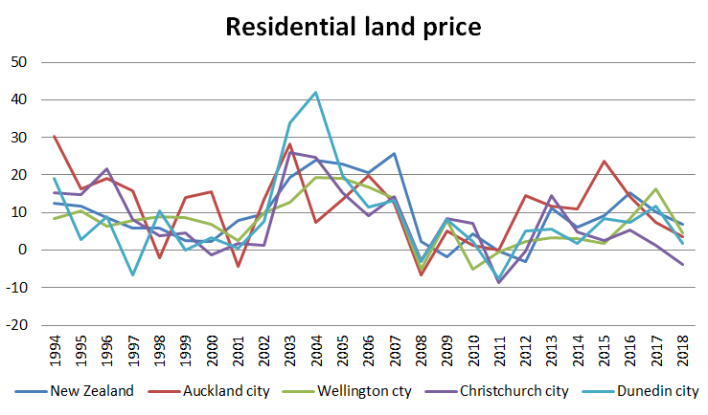

REINZ (2017) and Armstrong, Dunstan and Irrcher (2017)
In price measurement, a hedonic index is one where price (or log of price) is modelled against characteristics to identify and remove the price effect of the changing composition of products in terms of their price-determining characteristics. A ‘time-dummy’ hedonic index includes time as an independent variable and the price index is derived from the parameters estimated for time.
Or at the level of the dwelling, in the case of property indexes.
The index rose from a base of 1 at 1993 to 5.9 in 2018
That is: (490-330)/490 = 33%
See the ‘Dwelling sales price (SPAR Index) and ‘Dwelling land price (SPAR index)’ series accessed from the ‘market indicators’ tab on the NPS-UDC dashboard here: https://mbienz.shinyapps.io/urban-development-capacity/

